What are the Basic Elements of a Foundation Proposal?

Writing your first grant proposal may seem scary, especially if the funder doesn’t provide a form or template. Don't worry. Most grant proposals follow a very basic template. The guidance given below is very broad. Every proposal may be different. Keep a draft of boilerplate language from these sections to use for every grant proposal with slight tweaks depending on the funder. We are keeping this super simple here on purpose. Don’t overthink grant proposals.
1. EXECUTIVE SUMMARY: Aim for 5 paragraphs, but preferably less. People are busy. Make it brief and high impact. If it isn't, your proposal may be less competitive. This takes a lot of practice saying a lot in a short space. Some grant proposals will give you very little space, so practicing being brief is critical.
2. HISTORY AND ACCOMPLISHMENTS: Consider 2-3 paragraphs about the history and importance of your organization. You are tilling the soil; creating the conditions for a funder to sit up and pay attention. Draft your 5 most important accomplishments, even though you may only use 3 for each grant proposal. You will want multiple to choose from.

3. STATEMENT OF NEED: What is the problem in the world you aim to solve, and how are you uniquely suited to solve it? This is about half a page. Next, you plant seeds. This is a portion of the “statement of support” or “case statement” created by many nonprofits.
4. PROJECT DESCRIPTION: Now that you explained why you can solve it, describe in detail HOW you will do this. The project description is what they are giving you money to do. Focus on why the work is important and what outcomes, not outputs, you “hope” to achieve. This is usually less than 2 pages. If you are seeking general operating support, you should still describe the specific work of your organization.

5. BUDGET: Where will the revenue come from for this project (include funding from the funder you are pitching)? And how will you spend the funds? Be clear that the funder isn't the only source of money for this project. This can be a paragraph, bullets, or an attached spreadsheet.

6. CONCLUSION: Hit your top 3 points in 2 paragraphs.
7. APPENDICES: Unless requested not to do so, consider including 2-3 documents, images, statistics, or other material you are most proud of that will demonstrate the value of the proposal or the depth of the "statement of need."
If you need help with proposal writing, reach us at NonProfitFixer.com

See the infographic on the next page.

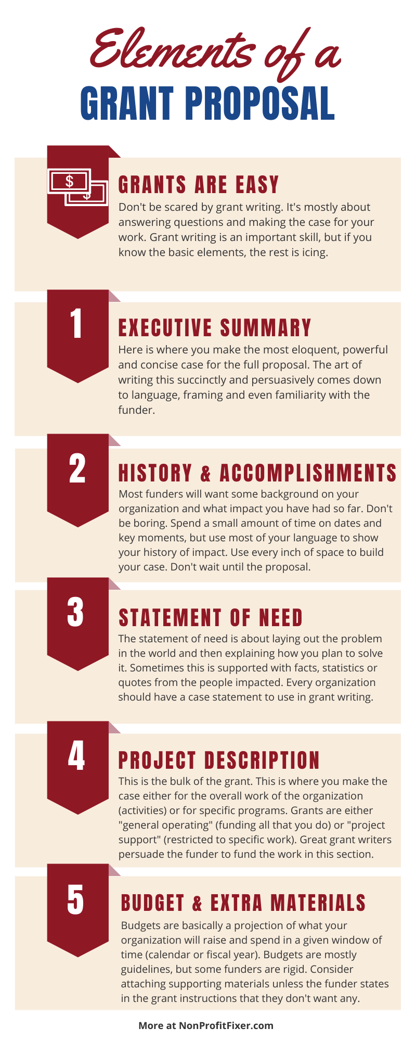

Go to NonprofitFixer.com for free and inexpensive tools, courses, and great tips and tactics and follow me on social sites.
No part of this document’s contents may be reproduced or disseminated without permission. © Mind the Gap Consulting, LLC.

